OOP 1st Assignment
BY
MD.Moshiur Rahman
I’D:0242220005101871

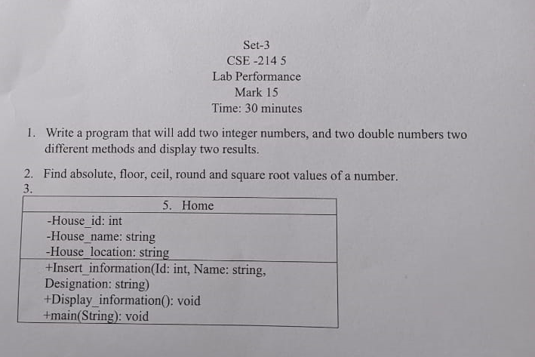

1.
package math;
import java.util.Scanner;
public class Math {

public static int addtwonumbers(int a,int b){
return a+b;
}
public static double addtwonumbers(double c,double d){
return c+d;
}
public static void main(String[] args) {
Scanner input = new Scanner(System.in);

int a;
System.out.println("Enter first integer Number: ");
a=input.nextInt();

int b;
System.out.println("Enter second integer Number: ");
b=input.nextInt();

double c;
System.out.println("Enter first double Number: ");
c=input.nextDouble();

double d;
System.out.println("Enter second double Number: ");
d=input.nextDouble();

int result1=addtwonumbers(a,b);
double result2=addtwonumbers(c,d);
System.out.println("First int. is: "+a);
System.out.println("Second int. is: "+b);
System.out.println("First double is: "+c);
System.out.println("Second double is: "+d);
System.out.println("Adding Two Integer Number: "+ result1);
System.out.println("Adding Two Double Number: "+ result2);
}

}

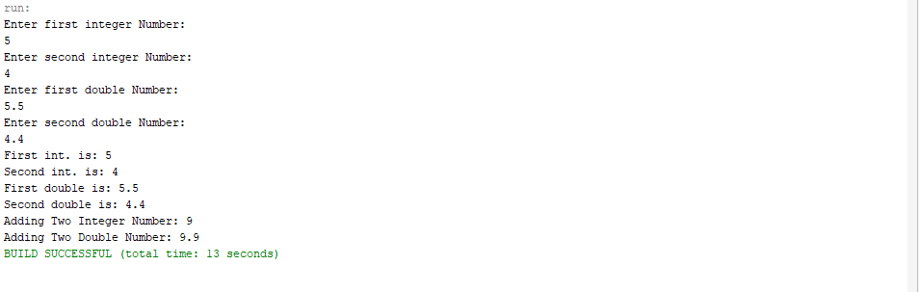

2.
package javaapplication13;
import java.lang.Math;
public class JavaApplication13 {
public static void main(String[] args) {
int a= 9;
System.out.println("Absolute: "+Math.abs(a));
System.out.println("Floor: "+Math.floor(a));
System.out.println("Ceil: "+Math.ceil(a));
System.out.println("Round: "+Math.round(a));
System.out.println("Square Root: "+Math.sqrt(a));

}

}

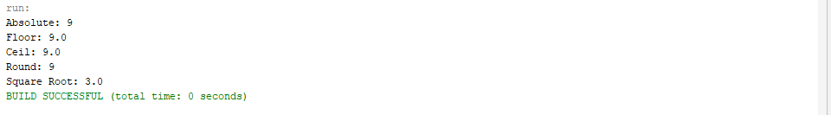

3.
package basicjava;

public class House {
private int houseId;
private String houseName;
private String houseLocation;

public House(int houseId, String houseName, String houseLocation) {
this.houseId = houseId;
this.houseName = houseName;
this.houseLocation = houseLocation;
}

public void insertInformation(int id, String name, String location) {
this.houseId = id;
this.houseName = name;
this.houseLocation = location;
}

public void displayInformation() {
System.out.println("House ID: " + houseId);
System.out.println("House Name: " + houseName);
System.out.println("House Location: " + houseLocation);
}

public static void main(String[] args) {
House house = new House(1, "Cozy Cottage", "123 Main Street");

System.out.println("Initial Information:");
house.displayInformation();

house.insertInformation(2, "Modern Mansion", "456 Elm Avenue");

System.out.println("\nUpdated Information:");
house.displayInformation();
}

}

